**Postgres Connection using workload Identity**

LIST OF CONTENTS:

1. AKS cluster with two features enabled: workload-identity and oidc-issuer.
2. create our managed identity (a user assigned managed identity).
3. create the database (an Azure Database for PostgreSQL - Single Server) and configure it.
4. deploy a fresh new namespace and a service account associated with our managed identity (still through its client ID).
5. Creation of Federated credentials.
6. Deploy a spring boot application.
7. Verification using command.

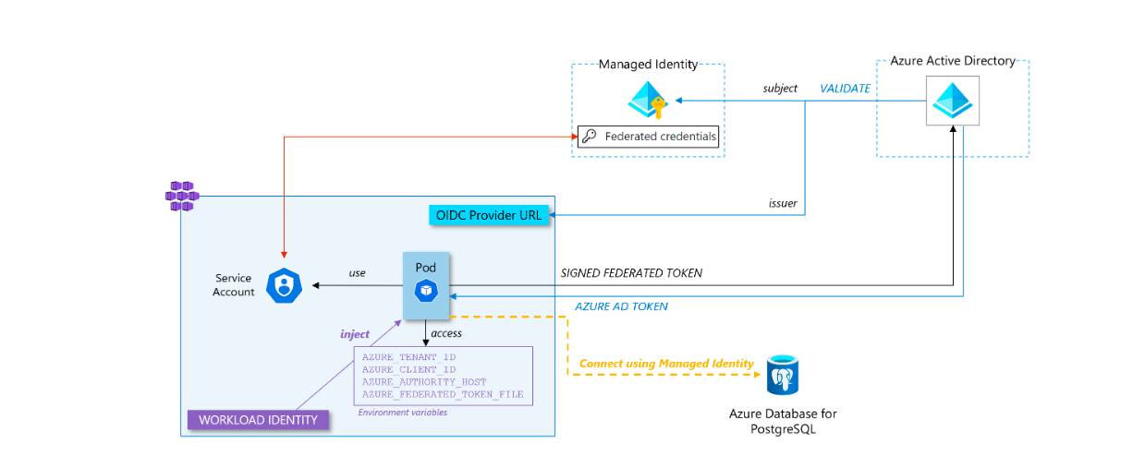

**AKS cluster with two features enabled: workload-identity and oidc-issuer.**

1.Exporting of variables

* export RESOURCE_GROUP="brilliorg"
* export CLUSTER_NAME="brilliocluster"
* export LOCATION="eastus"

2.command to create the compliant cluster.

* az group create --location $LOCATION --name $RESOURCE_GROUP
* az aks create -g ${RESOURCE_GROUP} -n ${CLUSTER_NAME} --enable-oidc-issuer --enable-workload-identity.

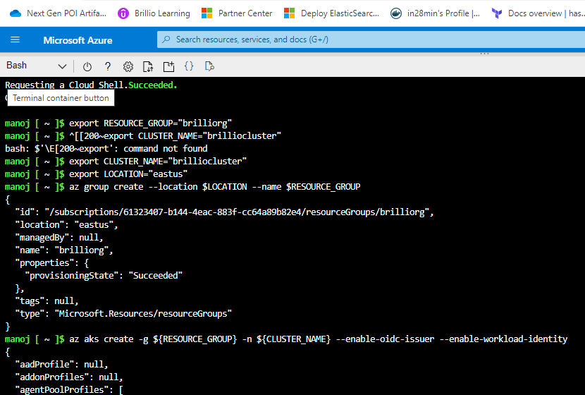

3.command to add the features to the existing cluster.

* az aks update -g ${RESOURCE_GROUP} -n ${CLUSTER_NAME} --enable-oidc-issuer --enable-workload-identity

4.Now to get its OIDC issuer URL.

* export AKS_OIDC_ISSUER="$(az aks show -n "${CLUSTER_NAME}" -g "${RESOURCE_GROUP}" --query "oidcIssuerProfile.issuerUrl" -otsv)"

Now, we have a Kubernetes cluster with an IODC issuer. This means that when a workload (a pod) asks for an access token to Azure AD (AAD), AAD will validate the signed token before exchanging it with an AAD access token.

**Managed identity**

Now, let’s create our managed identity (a user assigned managed identity)

1.Exporting the variables

* export SUBSCRIPTION="$(az account show --query id --output tsv)"
* export USER_ASSIGNED_IDENTITY_NAME="passswordless-demo-identity"

2. Create a managed identity and get its client id.

* az identity create \
* --name "${USER_ASSIGNED_IDENTITY_NAME}" \
* --resource-group "${RESOURCE_GROUP}" \
* --location "${LOCATION}" \
* --subscription "${SUBSCRIPTION}"
* export USER_ASSIGNED_CLIENT_ID="$(az identity show --resource-group "${RESOURCE_GROUP}" --name "${USER_ASSIGNED_IDENTITY_NAME}" --query 'clientId' -otsv)"

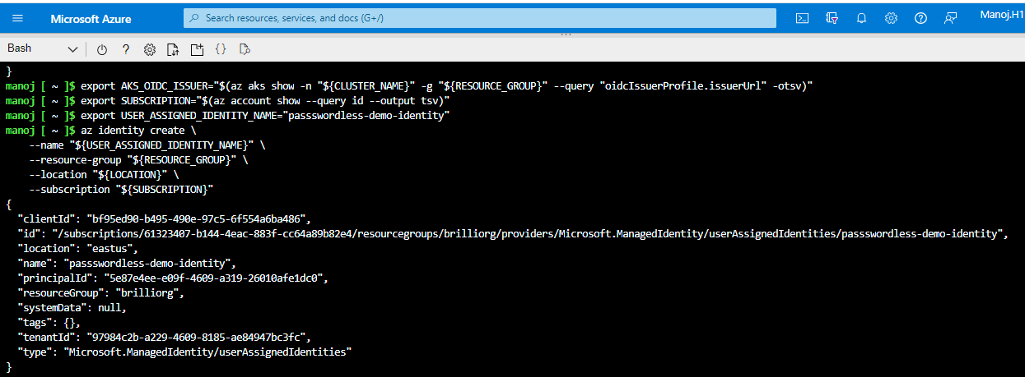

## PostgreSQL database

Now, let’s create the database (an Azure Database for PostgreSQL - Single Server) and configure it.

1. Exporting the variables.

* export DATABASE_NAME="brilliodb"
* export DATABASE_LOCAL_USER="brilliouser"
* export DATABASE_PASSWORD="Passworduser@23"

2. Creation of the PostgreSQL server instance.

* az postgres server create \
* --resource-group $RESOURCE_GROUP \
* --name $DATABASE_NAME \
* --location $LOCATION \
* --sku-name B_Gen5_1 \
* --storage-size 5120 \
* --admin-user $DATABASE_LOCAL_USER \
* --admin-password $DATABASE_PASSWORD \
* -o tsv

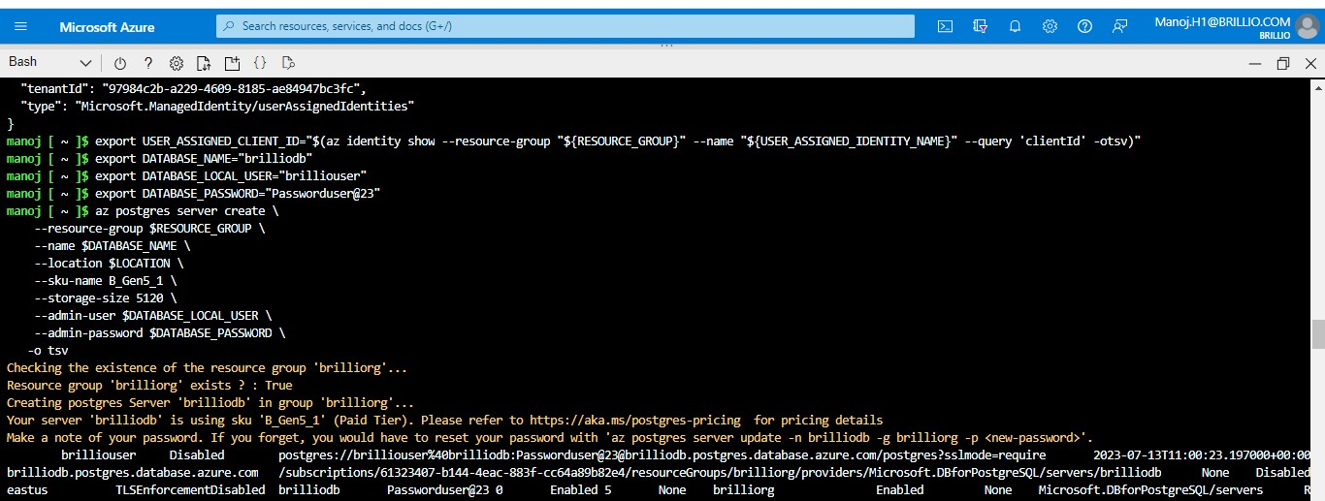

3. Configuring PostgreSQL Server firewall.

* az postgres server firewall-rule create \
* --resource-group $RESOURCE_GROUP \
* --name $DATABASE_NAME-database-allow-local-ip \
* --server $DATABASE_NAME \
* --start-ip-address 0.0.0.0 \
* --end-ip-address 255.255.255.255 \
* -o tsv

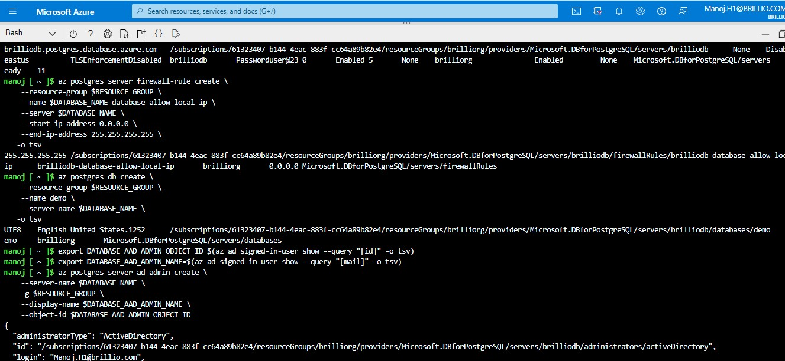

4. Configuring PostgreSQL Server database.

* az postgres db create \
* --resource-group $RESOURCE_GROUP \
* --name demo \
* --server-name $DATABASE_NAME \
* -o tsv

5. Add yourself as an Azure AD Admin.

* export DATABASE_AAD_ADMIN_OBJECT_ID=$(az ad signed-in-user show --query "[id]" -o tsv)
* export DATABASE_AAD_ADMIN_NAME=$(az ad signed-in-user show --query "[mail]" -o tsv)
* az postgres server ad-admin create \
* --server-name $DATABASE_NAME \
* -g $RESOURCE_GROUP \
* --display-name $DATABASE_AAD_ADMIN_NAME \
* --object-id $DATABASE_AAD_ADMIN_OBJECT_ID

6. You should now be in a situation where you have your Azure database for PostgreSQL instance ready and configured. The next step is to create the local user in PostgreSQL that corresponds to the managed identity (Note that you need the client ID of the managed identity created in the previous section).

* export DATABASE_APPLICATION_USER=myuser@$DATABASE_NAME
* export PGPASSWORD=$(az account get-access-token --resource-type oss-rdbms --query "[accessToken]" -o tsv)
* psql "host=$DATABASE_NAME.postgres.database.azure.com port=5432 dbname=demo user=<YOUR-AAD-ALIAS>@$DATABASE_NAME sslmode=require"

7. Now, you should be connected to the PostgreSQL server with psql, you need to type the following command to create the association between a local PostgreSQL role and your managed identity

* SET aad_validate_oids_in_tenant = off;
* CREATE ROLE myuser WITH LOGIN PASSWORD '<MANAGED_IDENTITY_CLIENT_ID>' IN ROLE azure_ad_user;
* GRANT ALL PRIVILEGES ON DATABASE demo TO "myuser";

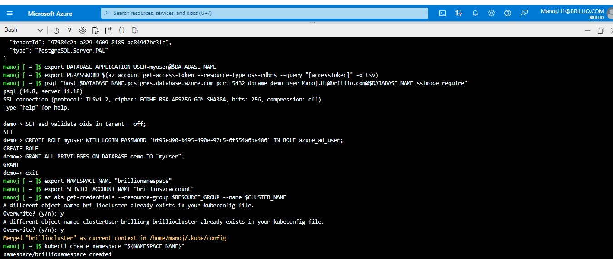

## Namespace & Service account

Now, let’s jump into the Kubernetes cluster to deploy a fresh new namespace and a service account associated with our managed identity (still through its client ID).

1.Exporrting the variables.

* export NAMESPACE_NAME="brillionamespace"
* export SERVICE_ACCOUNT_NAME="brilliosvcaccount"
* az aks get-credentials --resource-group $RESOURCE_GROUP --name $CLUSTER_NAME

2.Create namespace and environment.

* kubectl create namespace "${NAMESPACE_NAME}"

3.create the Service account.

cat <<EOF | kubectl apply -f -

apiVersion: v1

kind: ServiceAccount

metadata:

annotations:

azure.workload.identity/client-id: ${USER_ASSIGNED_CLIENT_ID}

labels:

azure.workload.identity/use: "true"

name: ${SERVICE_ACCOUNT_NAME}

namespace: ${NAMESPACE_NAME}

EOF

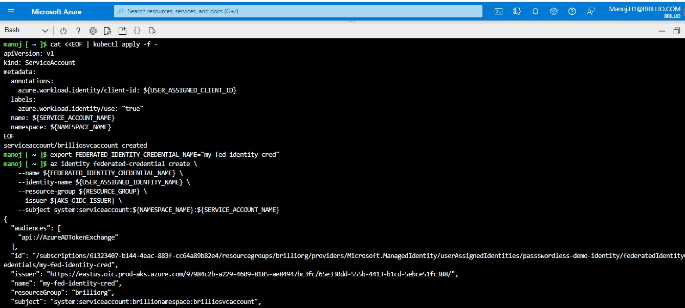

## Federated credentials

 The federation mechanism between an external workload and a user assigned managed identity is done by creating these federated credentials in the managed identity with the issuer and the subject that respectively match the OIDC provider URL of the Kubernetes cluster and the unique identifier of the workload in the cluster.

* export FEDERATED_IDENTITY_CREDENTIAL_NAME="my-fed-identity-cred".

1.Create the federated Credential.

* az identity federated-credential create \
* --name ${FEDERATED_IDENTITY_CREDENTIAL_NAME} \
* --identity-name ${USER_ASSIGNED_IDENTITY_NAME} \
* --resource-group ${RESOURCE_GROUP} \
* --issuer ${AKS_OIDC_ISSUER} \
* --subject system:serviceaccount:${NAMESPACE_NAME}:${SERVICE_ACCOUNT_NAME}



## Our Spring Boot application

1.Deploy the application

cat <<EOF | kubectl apply -f -

apiVersion: v1

kind: Pod

metadata:

name: spring-boot-demo-workload-identity-passwordless

namespace: ${NAMESPACE_NAME}

labels:

azure.workload.identity/use: "true"

spec:

serviceAccountName: ${SERVICE_ACCOUNT_NAME}

containers:

- image: aplantin.azurecr.io/spring-boot/spring-boot-demo-workload-identity-passwordless:1.2

name: spring-boot-demo-workload-identity-passwordless

env:

- name: AZ_DATABASE_NAME

value: ${DATABASE_NAME}

- name: AZ_DATABASE_USER

value: ${DATABASE_APPLICATION_USER}

EOF

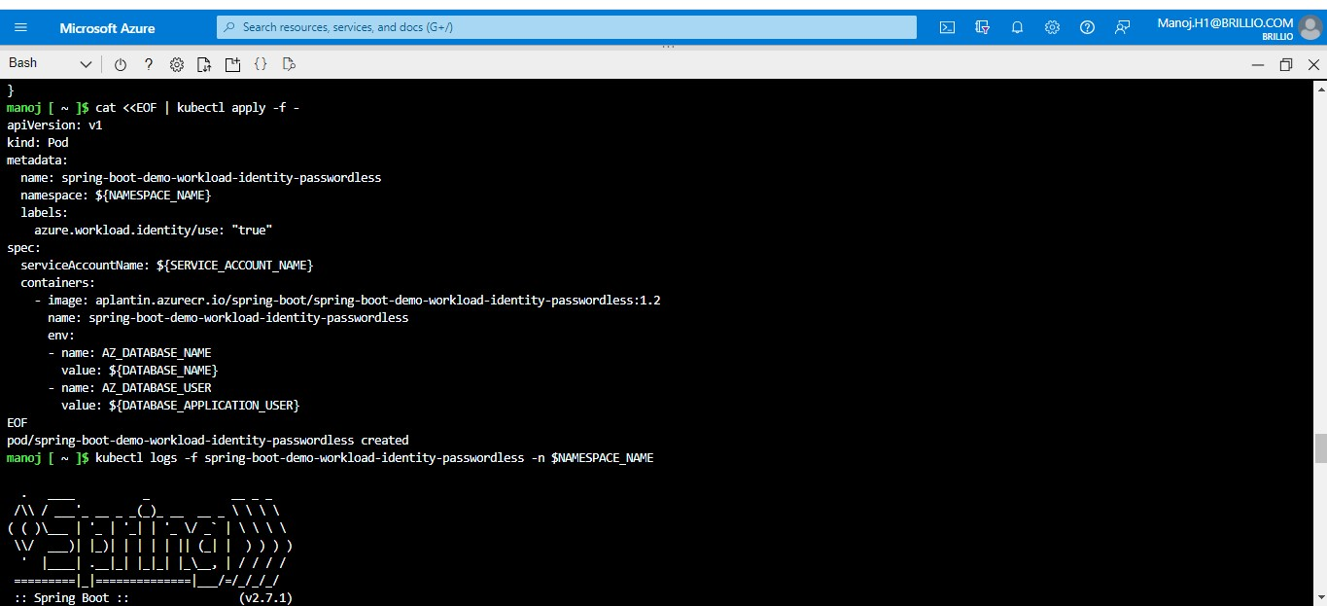

* Our pod uses the service account and - as the property workload.identity/use is set to true - has environment variables injected into its local FS. When the pod is created, the mutating webhook, which is part of the workload identity feature we activated on our cluster, projects a signed service account token to our workload’s volume and injects 4 environment variables to the pod (AZURE_AUTHORITY_HOST, AZURE_CLIENT_ID, AZURE_TENANT_ID and AZURE_FEDERATED_TOKEN_FILE) to pod.
* The signed federated token (which contains the issuer and the subject in its payload) is sent to Azure AD to get access to an Azure AD access token
* Azure AD will verify the federated token by getting the public key to control the signature of the federated token
* Once it has validated the federated token, Azure AD sends a valid access token
* The application uses the access token to authenticate to the database

## Verification

* kubectl logs -f spring-boot-demo-workload-identity-passwordless -n $NAMESPACE_NAME

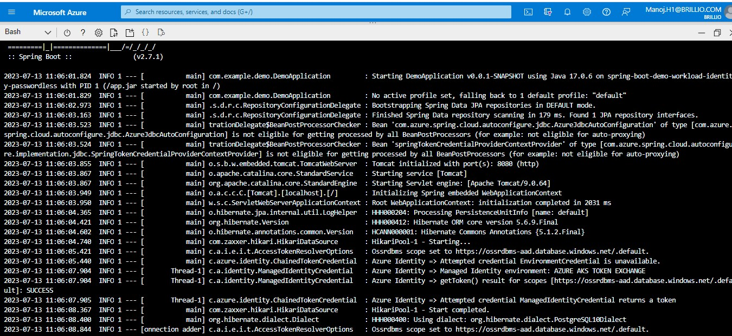

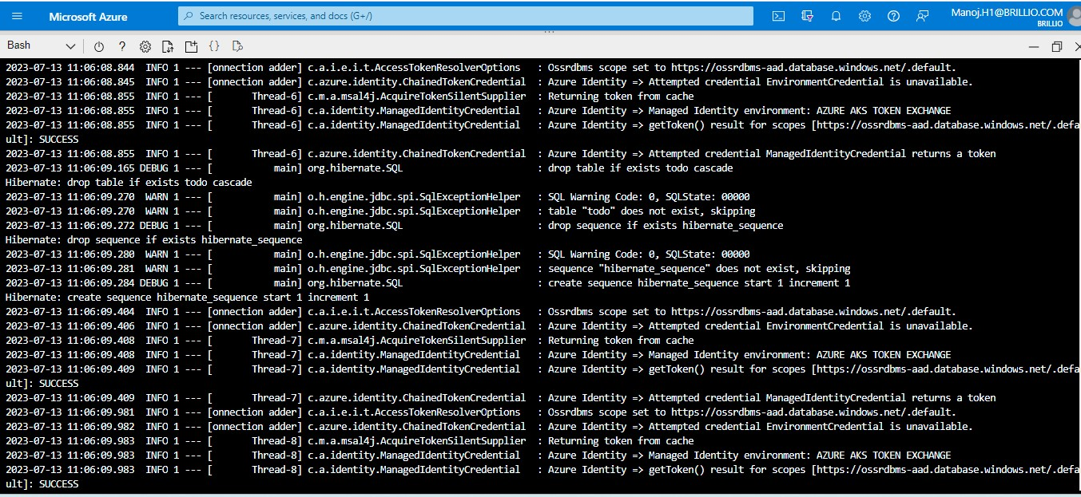

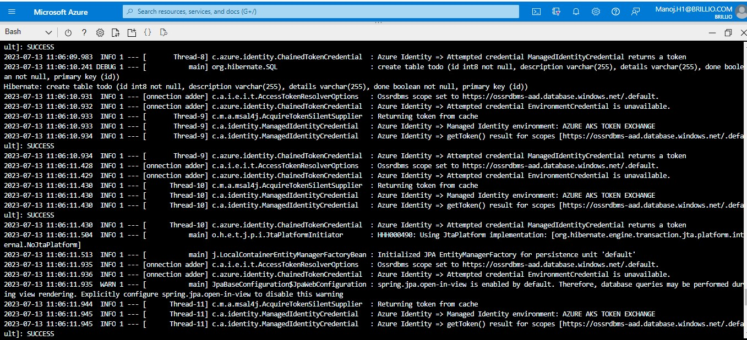

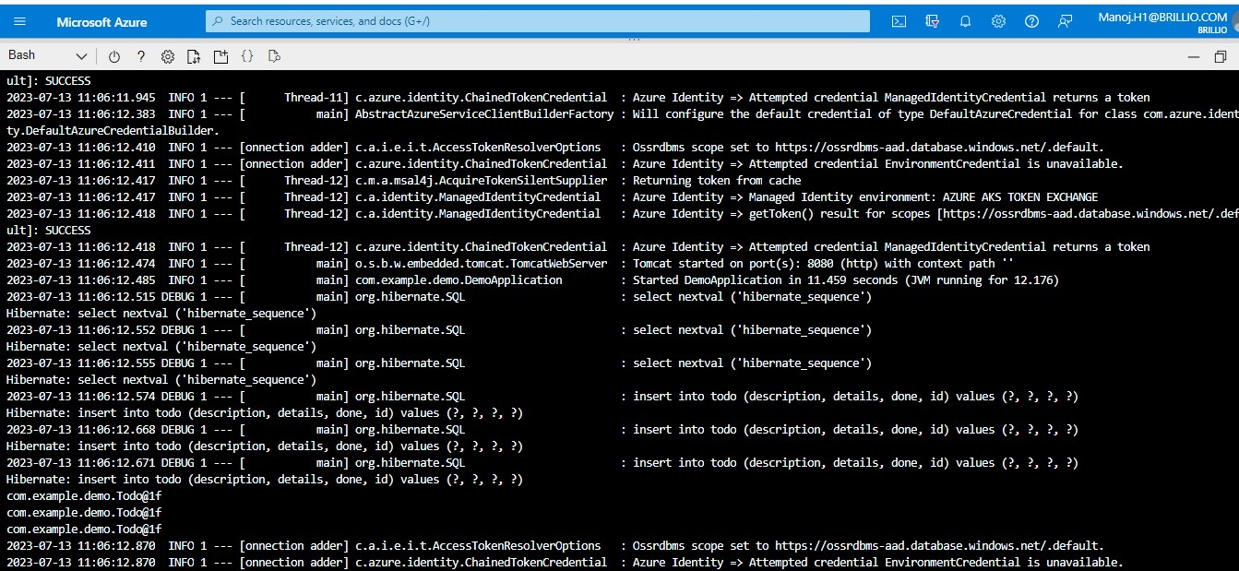

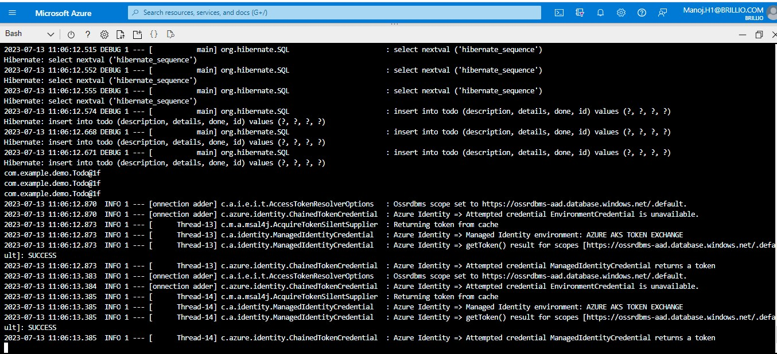

We have our Spring Boot application deployed in a Kubernetes cluster which connects to an Azure database for PostgreSQL without any credentials stored anywhere.

Referred Article:

<https://alexisplantin.fr/workload-identity-federation/>